**Inverting and Non-Inverting Comparator**

**Exp No: 4 Date: 10/02/2022**

**Objective:**

**To design, simulate and verify inverting and non-inverting comparator.**

**Software Required:**

LT Spice - XVII

**Theory:**

The Op-amp comparator compares one analogue voltage level with another analogue voltage level, or some pre-set reference voltage, VREF and produces an output signal based on this voltage comparison. In other words, the op-amp voltage comparator compares the magnitudes of two voltage inputs and determines which is the largest of the two.

We have seen in previous tutorials that the operational amplifier can be used with negative feedback to control the magnitude of its output signal in the linear region performing a variety of different functions.

We have also seen that the standard operational amplifier is characterised by its open-loop gain AO and that its output voltage is given by the expression: VOUT = AO*(V+ – V-) where V+ and V- correspond to the voltages at the non-inverting and the inverting terminals respectively.

The open-loop op-amp comparator is an analogue circuit that operates in its non-linear region as changes in the two analogue inputs, V+ and V- causes it to behave like a digital bistable device as triggering causes it to have two possible output states, +VCC or -VCC. Then we can say that the voltage comparator is essentially a 1-bit analogue to digital converter, as the input signal is analogue but the output behaves digitally.

Consider the basic op-amp voltage comparator circuit below: -

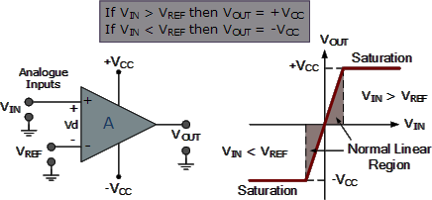

With reference to the op-amp comparator circuit above, lets first assume that VIN is less than the DC voltage level at VREF, (VIN < VREF). As the non-inverting (positive) input of the comparator is less than the inverting (negative) input, the output will be LOW and at the negative supply voltage, -VCC resulting in a negative saturation of the output.

If we now increase the input voltage, VIN so that its value is greater than the reference voltage VREF on the inverting input, the output voltage rapidly switches HIGH towards the positive supply voltage, +VCC resulting in a positive saturation of the output. If we reduce again the input voltage VIN, so that it is slightly less than the reference voltage, the op-amp’s output switches back to its negative saturation voltage acting as a threshold detector.

We can also see that the value of the output voltage is completely dependent on the op-amps power supply voltage. In theory due to the op-amps high open-loop gain the magnitude of its output voltage could be infinite in both directions, (±∞). However practically, and for obvious reasons it is limited by the op-amps supply rails giving VOUT = +VCC or VOUT = -VCC.

We said before that the basic op-amp comparator produces a positive or negative voltage output by comparing its input voltage against some pre-set DC reference voltage. Generally, a resistive voltage divider is used to set the input reference voltage of a comparator, but a battery source, Zener diode or potentiometer for a variable reference voltage can all be used as shown.

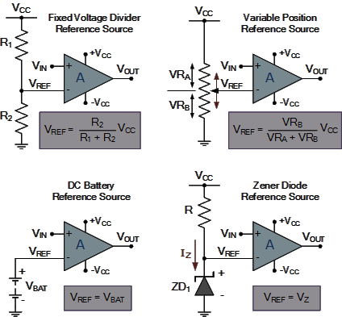

In theory the comparators reference voltage can be set to be anywhere between 0V and the supply voltage but there are practical limitations on the actual voltage range depending on the op-amp comparator being device used.

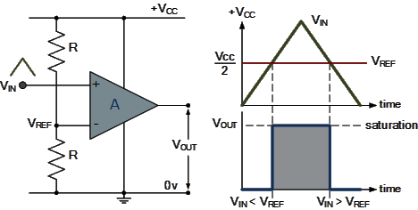

**Positive and Negative Voltage Comparators: -**

A basic op-amp comparator circuit can be used to detect either a positive or a negative going input voltage depending upon which input of the operational amplifier we connect the fixed reference voltage source and the input voltage too. In the examples above we have used the inverting input to set the reference voltage with the input voltage connected to the non-inverting input.

But equally we could connect the inputs of the comparator the other way around inverting the output signal to that shown above. Then an op-amp comparator can be configured to operate in what is called an inverting or a non-inverting configuration.

**Positive Voltage Comparator: -**

The basic configuration for the positive voltage comparator, also known as a non-inverting comparator circuit detects when the input signal, VIN is ABOVE or more positive than the reference voltage, VREF producing an output at VOUT which is HIGH as shown.

**Negative Voltage Comparator: -**

The basic configuration for the negative voltage comparator, also known as an inverting comparator circuit detects when the input signal, VIN is BELOW or more negative than the reference voltage, VREF producing an output at VOUT which is HIGH as shown.

**Non-inverting Comparator Circuit: -**

In this non-inverting configuration, the reference voltage is connected to the inverting input of the operational amplifier with the input signal connected to the non-inverting input. To keep things simple, we have assumed that the two resistors forming the potential divider network are equal and: R1 = R2 = R. This will produce a fixed reference voltage which is one half that of the supply voltage, that is VCC/2, while the input voltage is variable from zero to the supply voltage.

When VIN is greater than VREF, the op-amp comparators output will saturate towards the positive supply rail, VCC. When VIN is less than VREF the op-amp comparators output will change state and saturate at the negative supply rail, 0V as shown.

**Inverting Comparator Circuit: -**

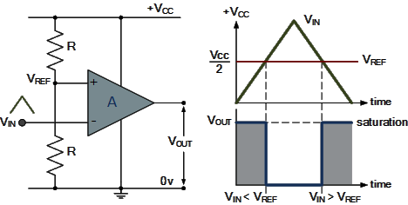

In the inverting configuration, which is the opposite of the positive configuration above, the reference voltage is connected to the non-inverting input of the operational amplifier while the input signal is connected to the inverting input. Then when VIN is less than VREF the op-amp comparators output will saturate towards the positive supply rail, VCC.

Likewise, the reverse is true, when VIN is greater than VREF, the op-amp comparators output will change state and saturate towards the negative supply rail, 0v.

Then depending upon which op-amp inputs we use for the signal and the reference voltage; we can produce an inverting or non-inverting output. We can take this idea of detecting either a negative or positive going signal one step further by combining the two op-amp comparator circuits above to produce a window comparator circuit.

**Procedure: -**

1. Open LT Spice and click on new schematic to start the circuit making.
2. Components needed are: wires, ground, resistor, op-amp and voltage sources.
3. Place them all in the required way as per the requirement of circuit analysis.
4. Perform required analysis like transient or ac etc. (simulation commands)
5. Run the schematic once the circuit is complete
6. Click above the ac input voltage source for the input signal
7. Click above the load resistor to obtain the output signal.
8. Analyse the input and output obtained from the circuit analysis on LT Spice.
9. Save the schematic and continue further analysis if required.

Inverting Comparator: -

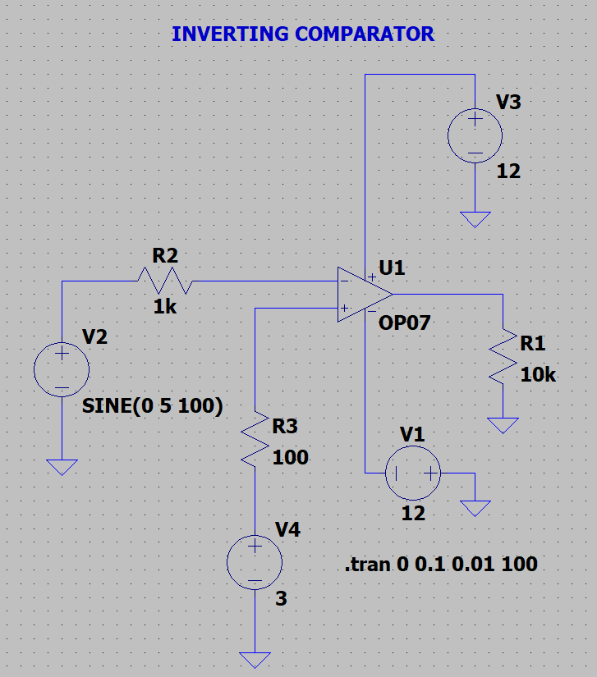

Output: -

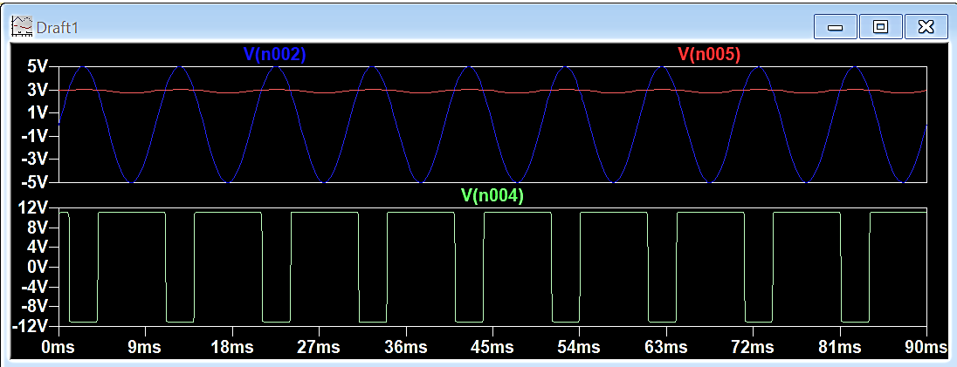

Non-Inverting Comparator: -

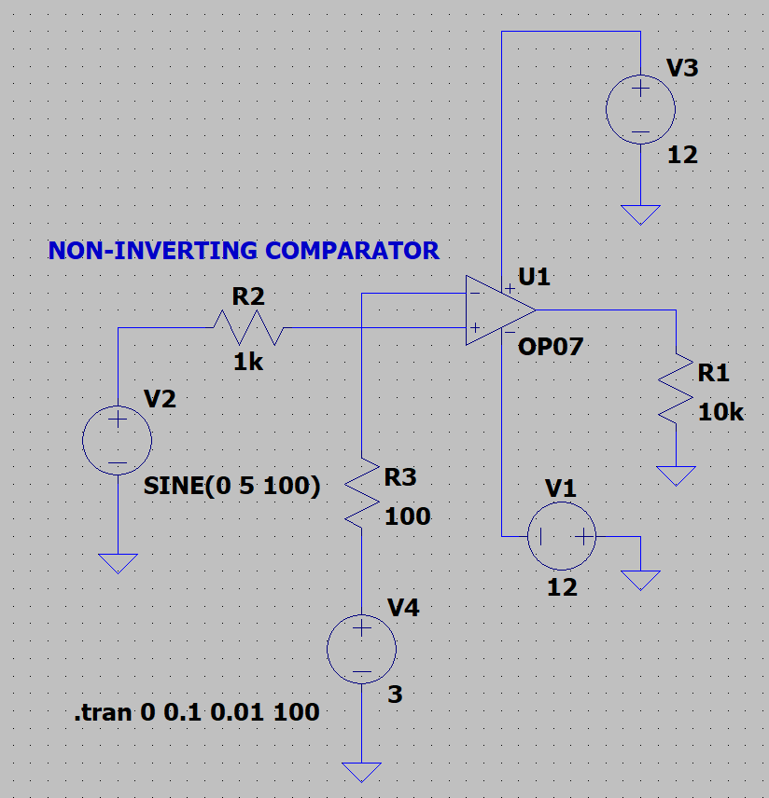

Output: -

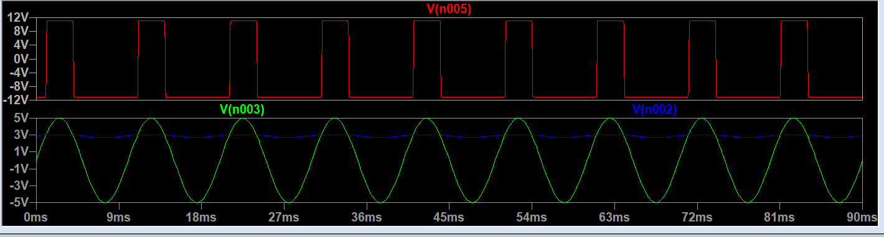

**RESULT: -**

**Hence, Inverting and Non-Inverting Comparator is designed, tested and verified using LTSPICE.**